**Foundation Certificate in Information Technology**

 **System Analysis & Design**

**Semester 02 – 2023**

**Tutorial 09 – Logic Modeling**

**Section 01- Structured Questions**

1. Draw the decision table to validate the following functionality.

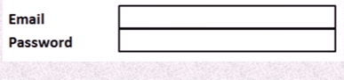

**Note: if the user entered the Email and password only it proceeds the login, otherwise it will show the error message**

1. The following table recommends the criteria used in giving discounts by a book publisher for different customers based on customer type and the number of books they order. Draw the **decision tree** for the following scenario.

|  |  |  |  |
| --- | --- | --- | --- |
| Rule | Type of customer | Ordered number of books | Discount |
| 1 | Book store | 40 or more than 40 books | 25% Discount |
| 2 | Book store | Less than 40 books | 5% Discount |
| 3 | Individual | 5-10 books | 5% Discount |
| 4 | Individual | 11-15 books | 10% Discount |
| 5 | Individual | More than 15 books | 15% Discount |

1. 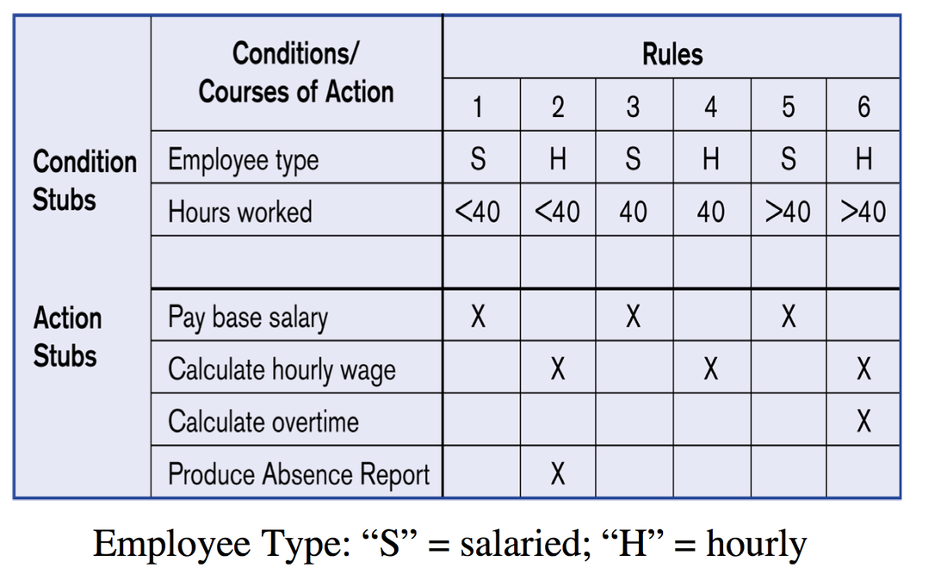Simplify the given decision table and draw the decision tree.
2. Summarize the following requirements in the form of a decision table

"A-Guide" is an online tour guide system where customers can plan their tour route. System supports three main functions: Create a route/path in the map, print map and renew membership. A registered member has to provide his/her login credentials to log into the system. If they are incorrect an error message is displayed. Once users successfully log in to the system they can plan the tour and get print outs.

When the user logs in if the membership expiry date is in that month the system will display a notification mentioning that the user has to pay the membership dues. In this case, he/she can renew the membership.

If a new member joins the system, he has to first register with the system by filling the registration form and paying the membership fee online. A new member can continue operation only after registering in the system by paying.

1. Company X sells merchandise to wholesale and retail outlets. Wholesale customers receive a two percent discount on all orders.  The company also encourages both wholesale and retail customers to pay cash on delivery. If they pay cash on delivery they will get an additional two percent discount.  If any buyer buys more than 50 units of products another two percent discount is given. Specify these requirements in the form of a decision table.
2. Consider the following function.

The Employee number (Eno) should be entered into the system. If the employee gets a salary below Rs: 25000 and is unmarried, he is entitled to receive a 10% bonus. If the employee gets a salary equivalent or above Rs: 25000 and is unmarried, he is entitled to receive 8% bonus. All the Married employees will get a 15% bonus regardless of the salary amount. The bonus percentage should be printed on the screen respectively.

1. Draw the decision tree for the above function.
2. Draw the decision table for the above function.
3. Consider the following function.

A store wants to run a discount campaign to attract new customers. The store owner decided to offer different discounts based on the following conditions.

If the customer is registered and who is older than 25 years, the total amount of transactions are greater than Rs.5000, then the customer is entitled to a discount of 50%.

For registered customers, those who are older than 25 years and the total amount of transactions are greater than Rs.5000 are entitled to get 10% discount.

If the customer is a registered customer and the age is under 25 years he/she is entitling to get 25% discount (For this discount the total amount of transactions is not considered).

For unregistered customers, no discounts are given. The store introduces a membership scheme for those customers.

1. Draw the decision table for the above function.
2. Draw the decision tree for the above function.

**Section 02- Multiple Choice Questions**

1. Decision tree uses
2. pictorial depictation of alternate conditions
3. nodes and branches
4. consequences of various depicted alternates
5. All of the above
6. None of the above
7. A decision table facilitates conditions to be related to
8. actions
9. programs
10. tables
11. operation
12. None of the above
13. The rule(s) to follow in constructing decision tables is (are):
14. a decision should be given a name
15. the logic of the table is independent of the sequence in which conditions rules are written, but the action takes place in the order is which the events occur.
16. Standardized language must be used consistently.
17. All of the above
18. None of the above
19. A Decision table
20. represents the information flow
21. Documents rules, that select one or more actions, based on one or more conditions, from a set of possible conditions.
22. gets an accurate picture of the system
23. shows the decision paths
24. In a Decision tree
25. the root is drawn on the left and is the starting point on the decision sequence
26. the branch, to be followed, depends on the conditions and decisions, to be made
27. the nodes represent the conditions, with the right wise of tree listing the actions to be taken
28. All of the above
29. None of the above
30. A Decision - Table is
31. a way of representing the information flow
32. a way of representing multiple conditions
33. a ways to get an accurate picture of the system
34. All of the above
35. None of the above
36. A decision table facilitates conditions to be related to
37. Actions
38. Programs
39. Tables
40. Operation
41. Difference between Decision - Tables and Decision Trees is (are)
42. value to end user
43. form of representation
44. one shows the logic while other shows the process
45. All of the above